## Literature Review

### Existing Methods for Estimating the MMR

#### The United National Maternal Mortality Estimation Inter-Agency Group (MMEIG) Estimates

The MMEIG is a collaboration between United Nations Member States, the WHO, the World Bank Group, the United National Population Fund (UNFPA), the United National Agency for Children (UNICEF), and the United National Department of Economic and Social Affairs, Population Division (UNDESA/Population Division). This collaboration produces estimates of regional and country-specific maternal mortality rates (MMR) between 2000 and 2023 for women between the ages of 15 and 49 [1]. The group has published multiple reports at different intervals in this time frame, with each report adding MMR estimates for country-years elapsed since the previous report and, in some cases, updating the model used to estimate the MMR [1].

The MMEIG considers data from a variety of sources to produce these MMR estimates. More specifically, it uses data from Member States’ civil registration and vital statistics (CRVS) systems, as well as information from specialised maternal mortality studies, surveys, censuses, and national surveillance data, as described in the background information. It only uses nationally representative data and thus does not consider data from health facility studies [3, 12]. Observations from sources other than CRVS systems and specialised studies were increased by 10% to account for underreporting due to deaths occurring early in pregnancy that may have been missed. Additionally, the MMEIG uses data from other United National agencies as inputs and covariates in its MMR model [1]. For example, the MMEIG sourced estimates of all-cause deaths among women aged 15 to 49, live births, total fertility and age-specific fertility rates, gross domestic product (GDP), skilled birth attendance rates, and deaths due to HIV from other agencies.

The MMEIG’s current MMR estimates are produced by a combination of two models. First, the Bayesian maternal mortality misclassification (BMis) model calculates adjustment factors for the provided CRVS data to account for under-reporting of maternal deaths and reporting errors [1,3]. These reporting errors are due to either incorrect medical classification of cause of death or incorrect application in applying the correct ICD code [1, 3]. Errors in CRVS data were defined in terms of sensitivity (probability of correctly classifying a maternal death) and specificity (probability of correctly classifying non-maternal deaths). Global and country-specific adjustment factors were calculated using specialised studies, as specialised studies are considered ‘gold-standard data’, and can thus provide a benchmark for the accuracy of CRVS data [3]. Previous studies have found that the level of misclassification in CRVS systems compared to specialised studies is typically around 50% [2]. Given that 53% of the total data input into the MMEIG’s maternal mortality estimate model comprised of CRVS data, these adjustment factors are essential to being able to accurately predict MMR [3]. Global estimates were calculated by fitting the BMis model to specialised study data from all countries and were used to determine the adjustment factors for countries with no specialised studies [3]. For countries with at least specialised study, the BMis model is fit to country-specific data, but with hyperparameters from the global model [3].

After using the BMis model to adjust the CRVS for errors, the MMEIG estimates the MMR per country per year using the Bayesian maternal mortality estimation (BMat) model [1]. In the latest iteration of the BMat model, the MMEIG estimates MMR for WHO Member States with populations of at least 100,000 people [3]. The BMat calculates MMR as the sum of non-HIV-related maternal deaths and HIV-related maternal deaths, where death was due to pregnancy-induced aggravation on the existing HIV/AIDS condition [1]. To reduce errors caused by under-reporting of all-cause deaths, the model first calculated the proportion of maternal deaths among all-cause deaths, then converted this measurement into the MMR [2].

The BMat estimates non-HIV-related MMR using a Bayesian hierarchical regression model [3]. Briefly, a hierarchical model determines a general trend and individual-specific deviations from the trends, which are referred to as random effects [15]. In the case of the BMat model, the non-HIV related maternal deaths were estimated with region and country specific trends, indicating the belief that countries in the same geographic have similar trends in their MMR [2]. The general trend was the global parameter values [2]. The model generates the general and individual trends using prior knowledge, with each of the ‘trends’ defined by a parameter that is drawn from a prior probability distribution [15]. These prior distributions are used to generate model parameters before fitting the model with data, with the size of the distribution indicating certainty in the parameter’s value [15]. The parameters are updated via Bayes’ update rule upon observation of data, with less data causing the parameters to more closely resemble the parameters drawn from the prior distribution [15].

The BMat model’s covariates are GDP per capita, general fertility rate, and presence of a skilled birth attendant. These covariates were representatives of three broad predictive groups: social and economic development (GDP), process (skilled care), and risk exposure (fertility) variables [1]. The expected non-HIV MMR was then multiplied by a data-driven multiplier, which adjusted the expected non-HIV MMR based on how closely the data indicated that the non-HIV MMR tracked with the covariates. For example, if the data indicates that the non-HIV MMR decreased more slowly than predicted by the covariates alone, the data-driven multiplier would reduce the MMR estimate [1]. The multiplier was estimated using an autoregressive ARIMA process [3]. The less data available for a specific country-year, the more strongly the covariates affect the non-HIV MMR estimate and the less strongly the effect of the data-driven multiplier [1]. This inclusion of a data-driven multiplier was a relatively new addition to the model, with versions of the model used before 2014 not including the multiplier [2]. The use of the data-driven multiplier was motivated by criticism that the earlier models which solely based their MMR predictions on country-specific covariates did not always echo country-level trends in maternal mortality, which were important reflections of a country’s progress toward meeting the Millenium Development Goals [2].

While the model was fit to all data provided by the country, it placed higher weight on values with lower error variances, which were derived from calculating the random error in the data collection processes. As a result of incorporating error, the final BMat estimates had smaller uncertainty intervals for countries with higher-quality data [1].

HIV-related MMR was estimated separately, as evidence indicates that HIV/AIDS is a prominent cause of maternal mortality in countries with ongoing HIV/AID epidemics, with studies showing that women infected with HIV have approximately 8 times higher risk of pregnancy-related death [1]. The HIV-related MMR estimate was calculated using data about the proportion of maternal and pregnancy-related deaths caused by HIV [2]. This calculation relies on a constant that defines the relative risk of dying from HIV/AIDS for a pregnant versus non-pregnant women, which is estimated in conjunction with experts and thus is semi-subjective [1,2].

The MMR estimates produced by the MMEIG also included maternal deaths that occurred between 2019 and 2023 due to the COVID pandemic [1].

##### Limitations of the UN MMEIG Estimates

While the UN MMEIG estimates are used by the international community to inform policy, they have limitations. The model’s use of sparse and low-quality maternal mortality data has meant that the MMR estimates generated by the model are associated with substantial uncertainty [2,3]. Unfortunately, the underreporting and misclassification errors that reduce data quality can be difficult to correct, as there is limited data about the extent of errors in different countries and systems [3]. These errors and the resulting uncertainty in the estimates limit the utility of the estimates [3]. This is especially true in countries without CRVS systems, which have a lower quality and quantity data quality [13]. Wide uncertainty bounds around the MMR estimates reduces the estimates’ utility and ability to inform policy, penalising countries with less developed data collection systems, which generally have higher MMRs and would thus benefit greatly from better, evidence informed programs [3, 13].

Low-quality training data can limit the usefulness of UN MMEIG MMR estimates in other ways. More specifically, sparse and low-quality data about a country’s

* Low data about prior
* What if country in same geographic region not similar

15:

* In many cases researchers fear committing to prior settings because they are unsure about their choices for the type and settings of the distribution. Therefore, they tend to choose wide priors to indicate little prior knowledge about the parameter values
* Wide priors are priors that allocate (approximately) equal probability density to a great range of values, such as a uniform distribution without bounds (Gelman, 2006). However, wide priors can be problematic. First, since the distribution is spread out across a wide range of values, the probability density on any specific parameter value is very low. Therefore, any effect is unlikely under the prior, as a wide range of effects is deemed plausible. This influences model comparisons: the support for the null hypothesis becomes increasingly large
* Another important issue is that wide priors are often improper probability distributions (Hobert & Casella, 1996). A prior is proper if two conditions hold: (1) All values of the probability distribution are equal to or greater than zero, and (2) the probability distribution sums to 1 for discrete data or integrates to 1 for continuous data. An example of a proper and an improper probability distribution are provided in Fig. 3. The figure shows two hypothetical priors for parameter θ. The first condition can be assessed by checking the y-values—both priors have only positive values as function output (0.1, 0.2, and 0.4). To assess the second condition, we need to sum up the function values. Panel A shows a proper distribution where the values sum to 1; panel B shows an improper distribution where the values sum to 1.2. A more common example of an improper prior is a uniform prior distribution ranging from minus infinity to infinity. In the case of improper priors, it is often impossible to obtain correct estimation of general and individual effects in hierarchical models because the resulting posteriors will again be improper probability distributions.
* As prior distributions influence model estimation and model comparison, it is important to choose suitable priors

In addition to data quality issues, there are some limitations associated with the specific models used to produce the UN MMEIG estimates. As described in the previous section, the UN MMEIG

* Arima negatives (13)
  + Linearity? Also of non-mmr as a whole
  + Can’t capture non-linear relationships between covariates?
  + Can’t show saturation of effect?
* Limited covariates
* Expert opinion and changing covariates
  + And how this can affect the model’s performance
  + Hiv estimates in general
* Pressure from member states
* Computational complexity

Other researchers have

<file:///Users/rosalitarosenberg/Downloads/16-AOAS1014%20(2).pdf> 2

* Model validation exercises suggested that the BMat model is reasonably well calibrated, but indicated, based on out-of-sample projections for more recent periods, that recent maternal mortality declines may be overestimated in developing countries. An investigation into the regression model used to estimate and project the systematic change in the non-AIDS MMR may result in the selection of an alternative model with improved performance.
  + The calibration of the current model was found to be satisfactory with respect to coverage of prediction intervals for left-out observations and confidence intervals for MMR estimates, and differences in MMR points estimates between full and training data set were small. With the development of BMat, we illustrated how a regression model can be extended through the addition of an ARIMA process to provide a more flexible model set-up to capture levels and trends in the outcome of interest, as indicated by the data, while still providing regression-based results for populations and/or time periods for which limited or no information is available
    - Can discuss limitations of ARIMA models for non-linear trends
* Important limitations to our study are related to maternal mortality reporting issues, the estimation of AIDS maternal deaths, and the dependency of the estimation of maternal mortality on the estimation of other demographic indicators.
* The second limitation of our study is due to the limited information on AIDS maternal mortality (Wilmoth et al. 2012), which complicates the reconstruction of trends in maternal mortality in countries with generalized HIV/AIDS epidemics. This limitation is of lesser concern for more recent years in which the contribution of AIDS maternal deaths to the overall number of maternal deaths has decreased. Lastly, because of the dependency of the maternal mortality estimation on the estimation of all-cause deaths to women of reproductive ages as well as the number of births, the challenges and limitations that apply to the estimation of these demographic indicators are also applicable to maternal mortality estimation. We did not include the uncertainty surrounding these demographic indicators into the uncertainty assessment for maternal mortality because such uncertainty assessments are generally not available. Future research work regarding the assessment of uncertainty in these demographic indicators may result in the reporting of uncertainty intervals for a wider range of demographic indicators and allow for a more complete uncertainty assessment for maternal mortality

#### The Global Burdan of Disease Estimates

Coordinated by the Institute of Health Metrics and Evaluation (IHME), the Global Burden of Disease Study (GBD) is an international scientific initiative that benchmarks major diseases, risk factors, and clinical intermediate outcomes [5]. The GBD uses a standardised approach to be able to compare its estimates across time, geographic populations, and health conditions [5]. GBD studies have been ongoing since 1993, with the estimates being reviewed by independent experts as well as the WHO Headquarters and Regional Offices [5]. Additionally, many of the studies have been published in prestigious journals like *Lancet* after being subject to peer-review cycles [5]. The GBD Studies’ strong reputation is apparent in their use in national planning by a variety of governments, such as the United Kingdom, Norway, and China [5].

The 2021 GBD Study produced estimates of maternal mortality for 204 countries between 1990 and 2021 using data from a diverse range of sources, including CRVS, verbal autopsy, sibling histories, surveillance, survey and census data, as well as police records and open-source databases [6]. The data is then cleaned, standardised, and any deaths reported with an unclear or incorrect cause-of-death are redistributed to a more likely cause of death [8]. This redistribution is performed by first assigning the garbage codes to a group of possible underlying causes of death. The garbage-coded deaths are then probabilistically redistributed among these different causes [8]. Data quality is quantified by a star rating system, where higher star estimates are associated with more complete, available data with a smaller presence of garbage codes [8].

The GBD Study estimated maternal mortality using cause of death ensemble modelling (CODEm) [4]. This involves generating multiple statistical models to capture the large number of factors that can co-vary with maternal mortality [4]. CODEm uses linear mixed effects regression (LMER) and spatiotemporal Gaussian process regression (ST-GPR) models, unlike the MMEIG estimates, which instead rely on Bayesian hierarchical regression [4]. Each of the models are used to test candidate covariates to maternal mortality, with each combination of covariates tested for plausibility based on the literature as well as statistical significance [4]. The candidate covariates are split into three groups depending on the level of evidence in the literature that supports a causal relationship between the covariate and the mortality measure [7]. Level 1 covariates have a strong causal relationship based on the biological disease process, while level 2 covariates have strong supporting evidence but no direct biological relationship [7]. Level 3 covariates have weak evidence supporting a causal relationship with the mortality measure [7].

The GBD 2021 Study used more covariates than the MMEIG, with the former using 19 covariates while the latter only used 3 (GDP, skilled birth attendance, and general fertility rate) [4, 1]. More specifically, the GBD study estimated maternal mortality using covariates including, but not limited to, age-specific fertility, maternal education, neonatal mortality ratio, skilled birth attendance, age-specific HIV mortality in females 10 to 54 years old, and age-standardised wasting [4]. Models based on this best set of covariates were then generated and tested on out-of-sample data [4].

The models’ weights in the ensemble were determined by their out-of-sample predictive performance [4]. The final mortality prediction is the mean of 1000 ensemble predictions, with each prediction being generated by one individual, component model. The likelihood of each model being chosen is determined by its weight [4]. The 1000 draws also allow the construction of a 95% uncertainty interval [4].

7:

* Based on the literature, we assign a prior on the direction of each covariate. Covariates that should increase the dependent variable are classified as having a positive prior, while those that should be inversely related are given a negative prior. If there is conflicting or inconclusive evidence as to the expected direction, the user can also specify that either direction would be valid
* So as to not have to retest each of these covariate combinations with the linear model family described below, we make the simplifying assumption that the inclusion of an additional country random effect will not change the direction or significance of the fixed effects; this assumption has held true in our testing and greatly reduces computational burden
  + But could it not change the size?
* Linear mixed effects models Model families 1 and 2 use a mixed effects model with fixed effects on covariates (selected via the mechanism explained below) and age dummies, plus hierarchical random effects by super-region, region, country, and age. The fixed effects allow us to capture broad trends in both age patterns and the impacts of key biological and environmental covariates. The random effects allow for improved estimation by adding intercept shifts by GBD super-region, region, and country (the 187 countries are grouped into 21 regions based on both geographical proximity and epidemiologic similarity; the 21 regions are further grouped into seven more general superregions), and changes in age patterns across regions and countries.
  + Assumes similar relationships between covariates
  + May have less data about age (for older mothers, teenage mothers), drawing to other
* Model families 3 and 4 begin with nearly the same mixed effects model used for families 1 and 2, but with the removal of the random country effect. The spatialtemporal models then utilize additional regression analysis to take into account how the dependent variable further varies across time, space, and age. This type of spatial-temporal regression model has been used in many applications, including the estimation of maternal mortality [36]. We do this by calculating the residual (predicted - observed dependent variable) for each data point and then run local regression in three dimensions on the residual. The process assumes that residuals contain valuable information that cannot be directly observed but nonetheless vary systematically across geographic region, time, and age group. This allows us to predict how much the observed dependent variable differs from the mixed effects model’s prediction and to account for these differences
  + Next, we weight all observations j relative to observation i. The key difference between our time weights and traditional LOESS weights is that we leave l as a parameter that can be tuned to increase or decrease how much smoothing occurs across time. We use l = .5 for countries that have data. If we were predicting the year 1995 in a time series from 1980 to 2010, then this would correspond to a time weight of 1 for observations from 1995, a weight of .42 for observations from 1994 or 1996, a weight of .27 for 1993 or 1997, a weight of .09 for 1990 or 2000, and a weight of close to 0 for 1980 or 2010. For countries without data, we have much less certainty in their trends; thus, we use a higher l of 2, which smooths out predictions and avoids issues of compositional bias.
    - But what if the trends are not smooth? Lose info about abrupt changes (e.g. crisis years)
* In order to perform the local regressions we must cycle through each observation in the dataset, weight every other observation in the dataset relative to it, and then find the weighted mean of the residual term
  + This is done to smooth trends over year, age, and geographical proximity to reduce noise in data and have combination of residuals from ‘nearby’ points
  + But greater smoothing with sparse data
    - When ω is set to its default value of 1, if j is in the adjacent age group, it receives a weight of .367, if it is two age groups away the weight is .135, etc. We chose this weighting scheme recognizing that mortality estimates typically change smoothly over age
    - The key difference between our time weights and traditional LOESS weights is that we leave l as a parameter that can be tuned to increase or decrease how much smoothing occurs across time. We use l = .5 for countries that have data. If we were predicting the year 1995 in a time series from 1980 to 2010, then this would correspond to a time weight of 1 for observations from 1995, a weight of .42 for observations from 1994 or 1996, a weight of .27 for 1993 or 1997, a weight of .09 for 1990 or 2000, and a weight of close to 0 for 1980 or 2010. For countries without data, we have much less certainty in their trends; thus, we use a higher l of 2, which smooths out predictions and avoids issues of compositional bias.
    - We use a value of ζ = .9 for countries with data, such that 90% of the weight in the local regression is given to observations from the same country, 9% is given to data from the same region but outside the country, and just 1% is given to data in other parts of the super-region. When there are no data for a country, we use ζ = .7, which gives 70% of the weight to data from within the region and 30% to data from other parts of the superregion; this reflects the fact that we wish to borrow more strength in such data-sparse areas
* In cases where we have both national and subnational observations for the country we’re predicting, we rescale the weights such that 90% of the in-country weight goes to the nationally representative data points and 10% is assigned to the subnational data. This reflects our desire to capture nationally representative trends
  + In contrast to UN MMEIG, which only uses national data (citing myself)
* This “predicted residual” is then added back onto the mixed effects prediction, creating an estimate that more closely takes into account aspects of the data that cannot be captured by a simple covariate model.
* Gaussian Process Regression (GPR) is a Bayesian estimation technique that is well-suited to estimating time series data because it maintains correlation in the uncertainty over time. The resulting estimates also track in-sample data very closely without significantly changing the predictions out of sample. We utilize GPR as the final step in our spatial-temporal component models. The inputs required are the mean function, amplitude, scale, degree of differentiability, and data variance.

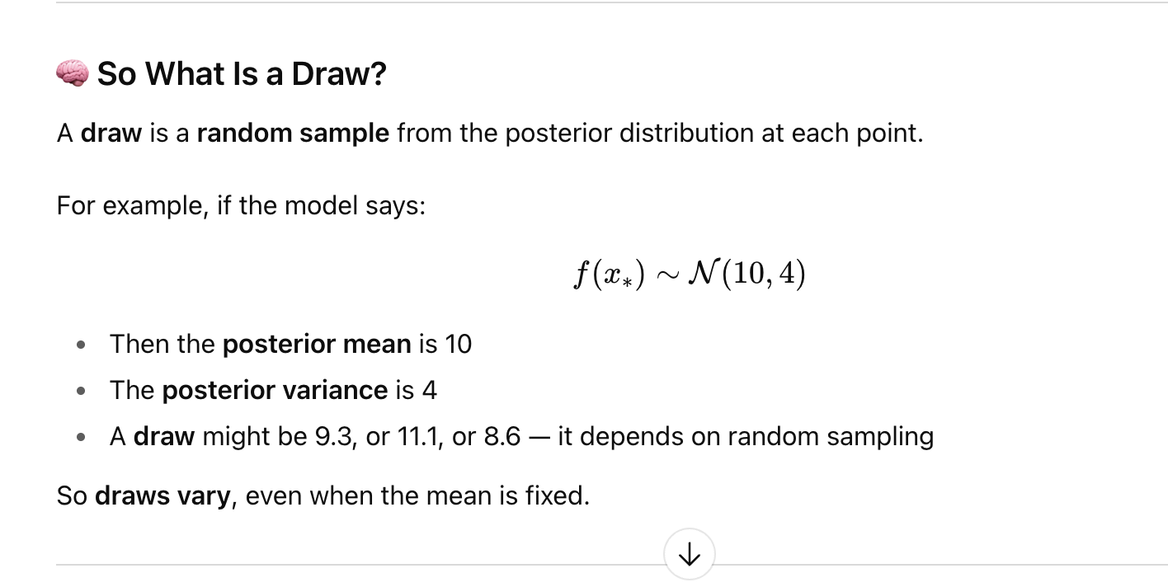

* Sampling variance can usually be estimated from each source on the basis of sample size and sample design. The more challenging task is to estimate the data variance due to nonsampling error. Work on child mortality and maternal mortality suggests that nonsampling variance is often substantially larger than sampling variance. In settings where multiple measurements in the same place and time period are available, iis possible to directly compute nonsampling variance. However, in most cases we have insufficient data in the same country-year to provide a direct measurement of nonsampling error. To approximate the nonsampling error, we first compute a simple spatial-temporal weighted average of the natural log of the death rates. We then estimate for three cases the MAD estimator of the residual from this weighted average: for countries with more than 10-year sequences of vital registration data (representing systems with the highest data recording), for subnational data when national data are also present for the country, and all other cases. The MAD times 1.4826 is a robust estimate of the standard deviation [84]. The MAD estimator of the residuals includes both sampling and nonsampling error as well as the systematic variation in death rates not adequately captured by the spatial-temporal weighted average. As such it is an overestimate of nonsampling variance (NSV). We believe it is preferable to overestimate rather than underestimate data variance and have used the NSV for each data type from this procedure for all models

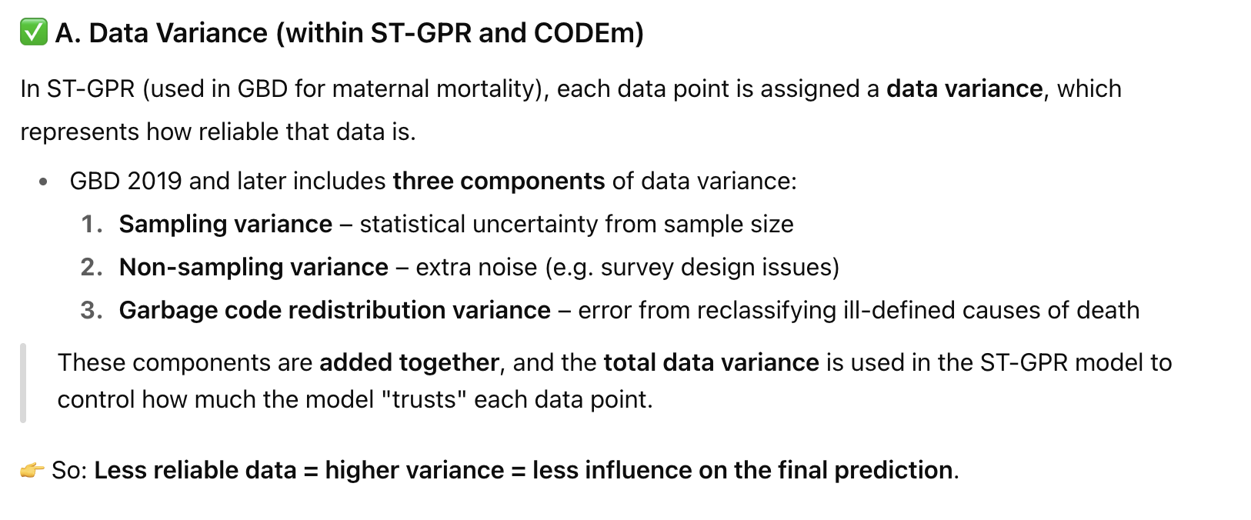

* In order to find uncertainty on model families 1 and 2, we first draw multiple times from the variance-covariance matrix of the fixed effects. We then simulate predicted death rates using these draws of beta, giving us an estimate of the parameter uncertainty. In order to capture the systematic variance in the model, we also add to each draw a random value from Normal(0, ssystematic) where s2 systematic is estimated as the square of 1.4826 times the MAD of the model residuals minus the estimated nonsampling variance.
* 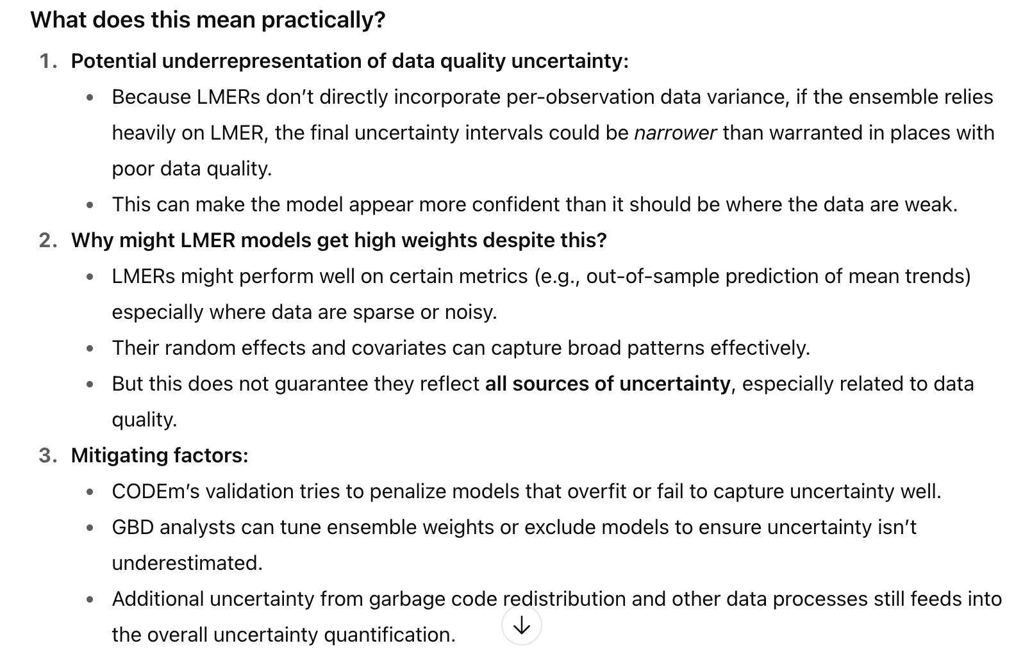
* Three components of data variance are now used in CODEm: sampling variance, non-sampling variance, and garbage code redistribution variance. The computation of sampling variance and non-sampling variance has not changed since previous iterations of the GBD and is also described in Foreman et al.46 Garbage code redistribution variance is computed in the CoD database process described in Section 2.7 of this appendix. Since variance is additive, we calculate total data variance as the sum of sampling variance, non-sampling variance, and redistribution variance. Increased data variance in GPR results in the GPR draws not following the datapoint as closely.

<https://www.thelancet.com/journals/lancet/article/PIIS0140-6736(24)00367-2/fulltext>

* First, sparsity of data or unreliability of data from specific regions, time periods, or age groups can influence the accuracy of our estimates, particularly poor data quality and coverage from western, eastern, southern, and central sub-Saharan Africa and south Asia
* Second, the quality of cause-of-death and verbal-autopsy data rely on accurately coded death certificates to the international standards set by the International Classification of Diseases and are subject to the practice of the doctor completing the death certificate, who may or may not have received training to facilitate comparability of reporting underlying causes of death. This process is further complicated by comorbidities at the time of death, which might affect the accuracy of both vital-registration and verbal-autopsy data sources. A key data-processing method for GBD is the re-allocation of incorrectly or vaguely assigned deaths—referred to as garbage codes[11](https://www.thelancet.com/journals/lancet/article/PIIS0140-6736(24)00367-2/fulltext)—to a more accurate, plausible underlying cause of death. This step helps to create comparable cause-specific estimates of mortality by underlying cause.
* Third, GBD assesses quality of cause-of-death data partly by examining levels of completeness, which indicate the accuracy with which the vital registration can capture deaths that occur in a location-year, irrespective of the percentage of garbage coding. Data completeness depends on the percentage of well-certified data, which is not necessarily indicative of low garbage coding
* Fourth, some sources of uncertainty, including the covariates used in models, are not captured in our estimation process.

<https://pmc.ncbi.nlm.nih.gov/articles/PMC12219140/#Sec17>

While the BAPC model offers robust trend estimation aligned with GBD’s epidemiological framework, it shares inherent limitations in capturing dynamic real-world complexities. The model does not account for climate-driven heat stress, which can raise preeclampsia risk by temperature increase [[32](https://pmc.ncbi.nlm.nih.gov/articles/PMC12219140/#CR32)–[34](https://pmc.ncbi.nlm.nih.gov/articles/PMC12219140/#CR34)], or sudden disruptions such as healthcare policy reforms (new prenatal care policies boosting case detection rates) or natural disasters that disrupt healthcare, displace populations, and elevate stress-related risks. These limitations stem from the model’s reliance on assumptions that may not fully reflect real-world complexity, as factors like non-epidemiological drivers, regional data heterogeneities, and short-term fluctuations are difficult to integrate, potentially leading to inaccurate predictions. Furthermore, the absence of comparisons with modern time-series or machine learning models (e.g., Prophet, Long Short-Term Memory (LSTM)) limits demonstration of relative methodological superiority, though such comparisons were constrained by the global scope, computational feasibility, and GBD’s prioritization of cross-disease consistency. Future studies could explore hybrid approaches combining BAPC with data-driven models in regions with robust surveillance data, while incorporating time-varying covariates (climate scenarios, policy interventions) to enhance predictive power and address these limitations.

Limitations:

* Garbage code redistribution accuracy (based on statistical assumptions)
* Not liasing with ministries (can mean they don’t accurately represent facts on the ground)
  + But not exposed to political pressures like the UN
* Black box of ensemble
* Still few features with lots of multicollinearity checks

Supplementary:

* All data were corrected for incidental HIV deaths by combining estimated HIV prevalence in pregnancy with relative risk (RR) of mortality during pregnancy for HIV-positive women to calculate a population attributable fraction (PAFs) that was then divided between incidental and maternal deaths based on RR of death in HIV-positive women during pregnancy. Incidental HIV deaths were removed from sibling history and census data, while maternal HIV deaths were added to vital registration, verbal autopsy, and surveillance data. This process is described in more detail in the appendix section on HIV/AIDS estimation.

#### The Global Maternal Health Microsimulation Model (GMatH) Estimates

As opposed to the MMEIG and GBD models that use aggregate measures to estimate country-level maternal mortality statistics, the GMatH model simulates individual women’s reproductive lifecycles to determine estimates of maternal mortality [9]. More specifically, the model uses monthly cycles to simulate each stage of pregnancy to determine the incidence of complications related to pregnancy and childbirth [9]. As part of this simulation, the model must estimate the probabilities of pregnancy, termination, and complications as a result of individual-level and institutional risk factors [9].

Parameters governing transition probabilities to different states within the model were estimated from probability distributions based on empirical data where possible, and on expert opinion where data was unavailable [9]. Relationships between parameters were similarly derived through a mixture of empirical data and expert opinion [9]. The uncertainty in the models’ inputs was captured setting the parameters’ prior probability distributions based on a 5-level hierarchical model. The model was then fit to empirical data [9]. This empirical data was sourced from UN agencies, randomized clinical trials, observational studies, census data, survey data, expert opinion, and meta-analyses [9].

The model used 5 sets of parameters, categorised into biological parameters, family planning parameters, health system parameters, obstetrical complications, and clinical interventions [9]. Examples of biological parameters include age-specific probability of pregnancy, anaemia status, and risk of miscarriage, while examples of family planning parameters include contraceptive preferences. Health system parameters include the type of care available at birth, the probability of recognition of complications, and underreporting of maternal deaths. Examples of parameters that capture obstetrical complications are the risk of postpartum haemorrhage and risk of indirect obstetric causes, such as deaths due to HIV aggravated by pregnancy. Finally, examples of the parameters representing clinical interventions are the efficacy and availability of interventions for certain complications, such as hypertension management, as well as use of elective interventions, such as caesarean sections [9].

Through this process, the GMatH has been used to estimate annual values for maternal mortality indicators like cause-specific and total maternal deaths, MMR, live births, and the lifetime risk of maternal death [9]. These estimates were produced for 200 countries and territories between 1990 and 2050. Additionally, the calibrated model was used to make projections for each year up to 2050 [9].

To test the model’s predictive accuracy, the authors calibrated the model’s maternal death estimates using CRVS data collected between 1990 and 2015, then compared the model’s estimates for 2016 to 2020 to the CRVS estimates for the same time period. The mean absolute error for the total number of maternal deaths in test set was 47.5.

<https://www.nature.com/articles/s41591-023-02310-x#Sec7> (gmath paper)

* Our annual global estimates are similar to those of the UN[10](https://www.nature.com/articles/s41591-023-02310-x#ref-CR10), but much higher than the GBD estimates[18](https://www.nature.com/articles/s41591-023-02310-x#ref-CR18), with large country-level differences across all three models. These large country-level differences have implications for both local and global planning and resource allocation, particularly as the top 20 countries are estimated to account for nearly 75% of global maternal deaths. Given the large uncertainty around many aspects of maternal health, our use of a fundamentally different modeling approach may help to shed light on potential reasons for such divergent estimates. Further research on the impact of some common inputs, such as the use of World Health Organization lifetables for both the UN and GMatH models (which only impact competing mortality risks and indirect maternal deaths in the GMatH model), could also help to identify areas for future model development.
* Including underreporting as part of the data-generating process in the model is more consistent with a Bayesian modeling framework in which parameters are random and empirical data are fixed, as opposed to making ex ante adjustments to the data used to the fit the model, which is the approach taken by the GBD and UN
* Although computationally intensive, the development of our structural model offers two major benefits over existing methods.
* . Our model also explicitly considers individual-level heterogeneity, as well as trends in demographic composition (urban or rural and education level) and how these trends impact various aspects of maternal health. In future work we plan to estimate trends in maternal mortality by subgroup, providing more detailed information on disparities in maternal mortality, both globally and within countries. Second, the use of a structural model allows realistic policy interventions (that is, counterfactual scenarios) to be simulated. Current estimates of maternal mortality are based on associative models (with aggregate predictors not amenable to policy intervention, such as gross domestic product)—although they can provide an estimate of the burden of maternal mortality, they cannot then be used to model interventions to provide actionable guidance on how the burden can be reduced.
* In addition to the uncertainty around underreporting, we faced data limitations for other model parameters. Although we leveraged empirical data when available, we were not able to set informative priors for some parameters (for example, quality of care) when calibrating the model. Additional research could therefore help to refine our assumptions and improve the precision of our estimates. For example, specific empirical indicators of quality of care would be especially useful because we fit these parameters solely via calibration owing to a lack of data. Estimates of the extent to which surveys may underestimate maternal mortality would be useful for the same reason.

<https://static-content.springer.com/esm/art%3A10.1038%2Fs41591-023-02310-x/MediaObjects/41591_2023_2310_MOESM1_ESM.pdf>

* We used a two-part hierarchical Poisson model to estimate the number of ANC visits based on DHS data. We used upper middle income priors for high income countries due to lack of DHS data in high income countries.
* Age of sexual debut is used in the model to simulate the beginning of a woman’s reproductive life-cycle
  + We analyzed DHS data (v531) from 1,150,813 women aged 35 and over from 230 surveys in 71 countries
  + Because no high income countries are available in the DHS data we used the priors estimated for upper-middle income countries to set priors for high income countries
* Number of Living Children
  + We used upper middle income priors for high income countries due to lack of DHS data in high income countries
  + Same for ‘desired number of children’
* Unmet need for family planning is defined as “women who do not want to become pregnant but are not using contraception” (DHS website).
  + We used upper middle income priors for high income countries due to lack of DHS data in high income countries
* We estimated the probability of SBA given home birth among 684,977 women in 75 countries from 257 DHS surveys. Due to lack of DHS data for high income countries we used the priors for upper middle income countries.
  + Sba = skilled birth attendant
* We calibrated all model parameters simultaneously, sampling from the priors (described above for each model parameter) to iteratively generate proposed parameter sets. Note that priors for model parameters were set using regression models of empirical data when possible (i.e. empirical Bayes/maximum marginal likelihood approach), while priors for other parameters which lacked empirical data were set based on subject matter knowledge and expert opinion
* e followed several guiding principles when developing the model structure and selecting the data sources used to inform the model parameters. For example, we used empirical data whenever possible to set prior probability distributions for parameters, including individual-level DHS data for more than 4.6 million women from 322 surveys in 83 countries (Appendix [A.2.1](https://www.nature.com/articles/s41591-023-02310-x#MOESM1)). We also relied on empirical data when developing the model structure and defining allowable relationships between parameters, aiming to balance model parsimony while still accounting for important mediating factors (for example, the impact of anemia on maternal health outcomes).

<https://researchsystem.canberra.edu.au/ws/portalfiles/portal/8849112/rm2013000054_journal_article.pdf>

* Dynamic ageing aims to reflect the ageing process in real life though it could make a model very complicated and computational expensive.
* a. Therefore, it might be necessary to make some assumptions to make estimation feasible, e.g. education choice happens before labour participation choice etc. In addition, one may also need to assume independent error terms and some other arbitrary assumptions in order to simplify the estimation. Although these assumptions are common in practice, they may lead to theoretical pitfalls and biased results when excessively used without proper testing. In addition, projections over time at the micro-level are particularly susceptible to misspecification error as modelling at this level involves more detail than in macro models, also current knowledge regarding micro-behaviour is not good enough to specify a fully dynamic
* Discrete time microsimulation models changes once per time period. Take demography for example, demographic modules in dynamic models are often constructed using annual transition probability matrices. Individuals are passed through a collection of transition matrices in each time period of the simulation (usually a year) to determine their simulated life paths, e.g. death. This method often assumes a sequential order of life events, however in reality they may be interdependent. As in the example given above and consequently the order in which the transition matrices are applied is very important. In the example given above, if marriage is determined first, then the potential fertility rate changes and similarly, a pre-marital pregnancy will increase the probability of getting married
* Over fitting may also be a potential issue when the list of explanatory variables grows. Due to the number of models that one microsimulation model can invoke and the budget/time constraints,

<https://www.jstor.org/stable/pdf/2998681.pdf>

* his is the trade-off between information intensity, on the one hand, and the capacity to make meaningful predictions, on the other hand. The dependent variables of human behaviour are always stochastic. Equally, our knowledge of the determinants of human behaviour is far from being complete. These two facts together imply that there are limits to the complexity of a projection model: beyond the certain point, the model becomes so complex that the resulting projections are no longer meaningful, being dominated by randomness. Th
  + in the micro model, all explanatory variables must be included at the individual level, and as a consequence, processes for generating time dependent explanatory variables (explanatory for the main process) must be included in the model as well. Thus, macro models suffer from information loss, while micro models suffer from high data requirements and a much larger influence of disturbance terms
  + (from me: meaning the model is being very influenced by noise)
  + So model must balance what parameters it chooses
* Suppose that we have perfect knowledge of the processes that govern population change over time and, in addition, that the current population is known with complete certainty. Because of the inherent stochastic nature of events, a model that embodies this knowledge will never be able to produce the future population with complete certainty. Since the future population is stochastic, the best a model can do is to provide the expected value of the future population. And indeed, this is exactly what a perfect macro model does. Now a macro model will never be perfect. If we forget about model misspecification, there are still two sources of possible imperfection: our hypotheses on the future values of the exogenous variables may be wrong; and the values of the parameters in the behavioural equations of the model are typically based on statistical inferences made from empirical data, not on knowledge of the 'true' parameter values. Thus, the macro projection is subject to random variation: it produces a certain statement about the future, but this statement might have been different. However, if our hypotheses are optimal (in the sense of reflecting the best guesses that we can make) and the parameter estimates are unbiased, the macro projection model will also be 'unbiased': on average, it will produce that projected value which is the expected value of the future population (i.e. which the future will reach on average). The sources of possible imperfection mentioned in the preceding paragraph operate for any kind of projection model, not just for macro models. Thus, also a microsimulation projection is subject to the same type of random variation, or randomness as we will call it. How
* a starting population is needed of individuals with all their relevant characteristics (state variables and covariates). This starting population, which is the initial database for the microsimulation model, is a sample from the total population and thus subject to random variation: the joint distribution of state variables and covariates within the initial database is random. This so-called starting-population randomness can be reduced by increasing the size of the initial sample, but it cannot be removed (unless the total population is included in the database, which is clearly unpractical). Any deviation of the sample distribution from the population distribution causes the projected population to deviate from its expected value.
* The specification of the theoretical model describes which explanatory variables determine the input parameters (probabilities) and in what way. In microsimulation models, one is easily inclined to relate the input parameters to as many explanatory variables as possible: the relationship between demographic states and demographic events can often be defended theoretically, and the incorporation of complex relationships does not present many technical problems (unlike in macro models where the state space size is a limiting factor). However, the more explanatory variables are included in a micro simulation model, the larger the degree of randomness to which the model outcomes are subject. There are two sources of specification randomness. First, each relationship between input parameters and explanatory variables has to be estimated from empirical data. Each empirical estimate is subject to measurement error, typically expressed in standard errors of the estimates. Th
* We would like to stress that specification randomness is quite different from misspecification error. If the model is misspecified, it gives a wrong description of the real world and the projection results will be systematically biased. I
  + Our overall conclusion is that the specification of a microsimulation model should be kept as simple as possible, in order to keep the extent of the specification randomness strictly under control. Given
* Competing risks are problematic because of the issue of multiple events. In discrete time, the possibility of multiple events occurring within one unit time interval should be taken into account, even if the time interval is relatively short (typically, one year). If two events are simulated to occur, the order in which they occur could well be quite relevant: if a woman is simulated both to have a child and to die within the same interval, the existence of her baby crucially depends on which event occurred first. However, in a discrete-time model, by definition nothing is known about the timing of events within the unit time interval. One possibility would be, to model these events simultaneously, by defining one probability for each compound event (combination of elementary events). In the example, there would be three such compound events: to die without child; to die with child; to survive with child. However, for models with a large number of elementary events, such an approach would quickly become infeasible, not to mention the lack of sufficient empirical information.

ME: my model can learn to ignore variables

<https://journals-sagepub-com.virtual.anu.edu.au/doi/epdf/10.1177/0894439310370085>

* Larger scale micro-simulation models require countless parameters estimated from various data sources that are fre-quently not easy to reconcile; policy simulation requires tiresome accounting; and due to theircomplexity, microsimulation models are always in danger of becoming hard-to-operate-and-understand black boxes.
* The central limitation of microsimulation lies in the fact that the degree of model detail does not go hand in hand with overall prediction power. The reason for this can be found in what is called randomness caused by accumulated errors and biases of variable values
  + In dynamic models, randomness is further increased by the stochastic nature of microsimulation models
* There is a trade-off between the additional randomness introduced by additional variablesand misspecification errors caused by models that are too simplified. This means that the feature thatmakes microsimulation especially attractive, namely the large number of variables that models caninclude, comes at the price of randomness and the resulting prediction power that weakens ordecreases as the number of variables increases. This generates a trade-off between good aggregatepredictions versus a good prediction regarding distributional issues in the long run, a fact that mode-lers have to be aware of.
* Besides the fundamental nature of this type of randomness, its extent also depends on data relia-bility or quality. In this respect, we can observe and expect various improvements as more and moredetailed data become available for research, not only in the form of survey data but also administra-tive data.
* he third type of drawback is related to development costs. Microsimulation models have a needfor high-quality, longitudinal (in the case of dynamic models) and sometimes highly specific typesof data—and there are costs involved to acquire and compile such data. Note that such costs are notexplicit costs associated with the actual microsimulation itself but represent the price to be paid forresearch in general and informed policy making in particular.Microsimulation models also usually require large investments with respect to both manpowerand hardware. However, these costs can be expected to further decrease over time as hardware pricesfall and more powerful and efficient computer languages become available

<https://pmc.ncbi.nlm.nih.gov/articles/PMC5674830/pdf/40748_2017_Article_59.pdf>

* Maternal mortality is much higher in developing countries compared to developed nations owing to lack of adequate medical care; high prevalence of infectious diseases,higher total fertility rate and due to health care system difference. Countries with high maternal mortality ratio have less reliable vital statistics registry system; as a result level of maternal mortality is usually underestimated and little information is available regarding locally specific risk factors for maternal death [2, 3].
* or developing countries, neither antenatal care nor the presence of a skilled birth attendant was related to maternal mortality until 40 to 60% coverage was achieved; only then did mortality decrease. In contrast, there was a clear decrease in maternal mortality as cesarean section rates increased from 0 to about 10%, with little change thereafter.

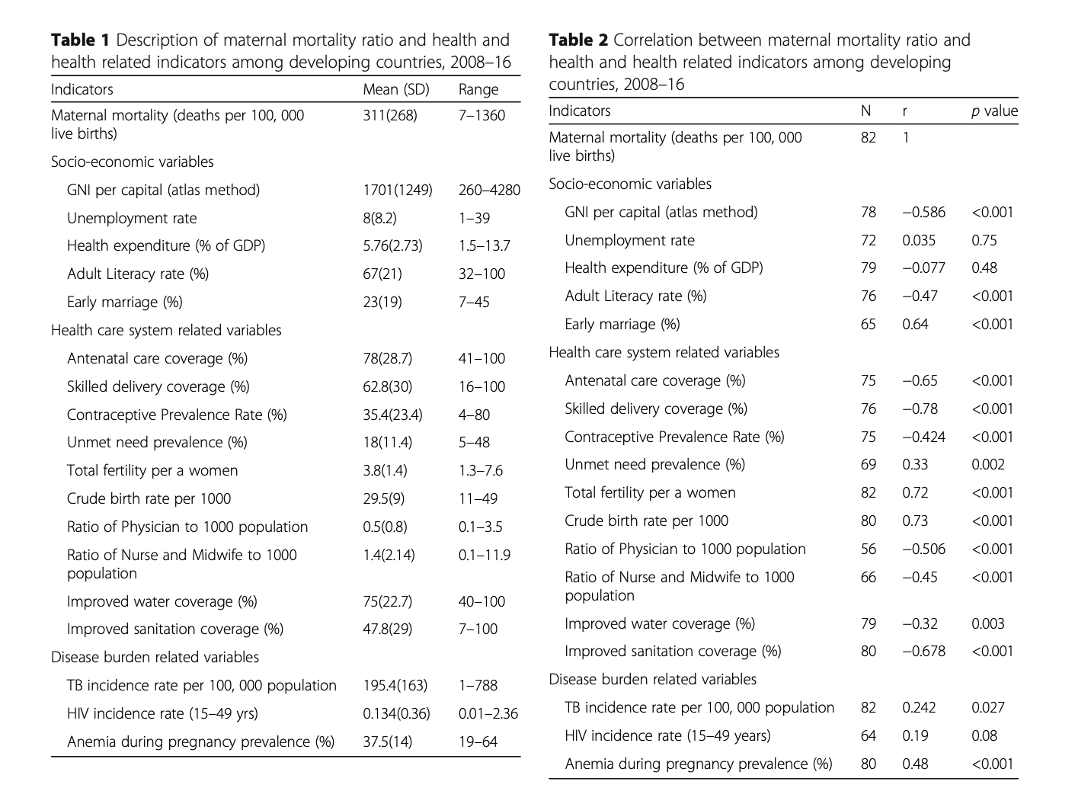

* <https://www.thelancet.com/journals/langlo/article/PIIS2214-109X(23)00468-0/fulltext#:~:text=5%2C6,a%20stagnation%20in%20the%20MMR>.
* In this context, quality of care emerges as a central attribute of health services that can exert a protective effect on maternal health. Quality is a multidimensional concept translated into maternity services as the interplay of available human resources, infrastructure, commodities, and efficient processes, producing a positive care experience for the woman and favourable health outcomes at an acceptable cost.[74](https://www.thelancet.com/journals/langlo/article/PIIS2214-109X(23)00468-0/fulltext) However, and often due to poor quality of care, health services might not be able to modify or counterbalance adverse social determinants, individual-level factors, lifestyles, and exposures. The default health system configuration in many low-resource settings features inadequate or suboptimal equipment for screening and diagnosis, health-care worker shortages or competency challenges, inadequate use of effective maternal health interventions, or a combination of these problems, which together coalesce into the so-called too little, too late situation.[12](https://www.thelancet.com/journals/langlo/article/PIIS2214-109X(23)00468-0/fulltext) Preventable deaths continue if the chain of events leading to maternal mortality is not interrupted. For instance, pre-eclampsia is easy and inexpensive to diagnose, and potentially preventable with health-care commodities (eg, aspirin); however, the underdiagnosis of pre-eclampsia and underuse of preventive measures continue to drive pre-eclampsia-related mortality and morbidity in low-resource settings. Furthermore, health services can be influenced by social forces. For example, disrespect, abuse, and mistreatment of women within maternity services often reflect gender, ethnic, or social class biases against women and are perpetrated by health-care providers, many of whom are women and themselves affected by the same forces and hierarchies within the health services.[75](https://www.thelancet.com/journals/langlo/article/PIIS2214-109X(23)00468-0/fulltext)
* Although health systems have the potential to attenuate adverse health factors, they can also cause hazards. Complications of health interventions (ie, iatrogenic factors) are an important contributor to all-cause mortality and a substantial cause of or contributing factor to maternal mortality.[76,77](https://www.thelancet.com/journals/langlo/article/PIIS2214-109X(23)00468-0/fulltext) Health interventions are designed and implemented to improve situations in which the anticipated benefits outweigh potential risks. For example, a medically indicated caesarean section can be a life-saving intervention, and the underuse of caesarean section is associated with poor maternal and perinatal health outcomes. However, when health interventions are implemented in situations with relatively low risk of adverse outcomes, their benefits might not outweigh their risks, and indeed could lead to harm. The same intervention applied to a situation with a lower risk of adverse outcomes might have a different result. For example, the short-term and long-term complications of a non-medically indicated caesarean section outweigh the potential benefits for both the woman and the baby.[78](https://www.thelancet.com/journals/langlo/article/PIIS2214-109X(23)00468-0/fulltext) Ensuring rational use of caesarean sections is of great importance, especially in settings without reliable access to safe surgery.[78,79](https://www.thelancet.com/journals/langlo/article/PIIS2214-109X(23)00468-0/fulltext) Promoting the rational use of health interventions and preventing interventions that are not medically justified (ie, quaternary prevention) nor desired by the informed care recipient can be a strong complement to quality of care, good health outcomes, and a positive care experience.[80](https://www.thelancet.com/journals/langlo/article/PIIS2214-109X(23)00468-0/fulltext) In addition, using non-medically indicated health interventions can be a substantial resource drain (for both society and the individual) that could further complicate subsequent pregnancies, especially in resource-constrained settings.[78–80](https://www.thelancet.com/journals/langlo/article/PIIS2214-109X(23)00468-0/fulltext)

<https://pubmed.ncbi.nlm.nih.gov/17274999/>

* **Results:**Stillbirth and maternal mortality rates were strongly correlated, with about 5 stillbirths for each maternal death. However, the ratio increased from about 2 to 1 in least developed countries to 50 to 1 in the most developed countries. In developing countries, as the cesarean section rates increased from 0 to about 10%, both maternal mortality and stillbirth rates decreased sharply. Skilled delivery attendance was not associated with significant reductions in maternal mortality or stillbirth rates until coverage rates of about 40% were achieved. Four or more antenatal visits were not associated with significant reductions in maternal deaths until about 60% coverage was achieved. The same measure was associated with only modest decreases in stillbirth.

#### Comparison of the MMEIG, GBD, and GMatH Maternal Mortality Estimates

The authors of the original paper describing the GMatH model compare their model’s maternal mortality estimates to the latest estimates produced by the UN’s MMEIG and the GBD Study. The authors found substantial country-level differences in the estimates produced by the three models, with the GMatH global estimates being similar to the MMEIG’s global estimates but notably higher than the GBD’s global estimates [9]. These global differences were shown in the figure below. The deviations in the models’ estimates could result in the development of differing policies depending on which model is used as evidence for the policy [9].

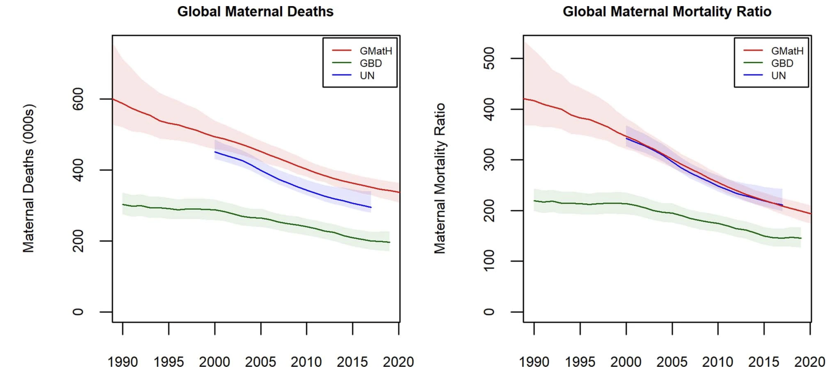

<https://www.nature.com/articles/s41591-023-02310-x/figures/3>

Given these differences, the authors of the GMatH model describes their hope that their intrinsically different modelling approach could provide insight into the reason why the models results have diverged [9]. This also motivates my proposal for the use of a machine learning based approach, which may shed further light on this problem. The machine learning approach is further motivated in the next few sections.

#### Limitations of the MMEIG, GBD, and GMatH Models

* My method could be a pathway to getting national estimates

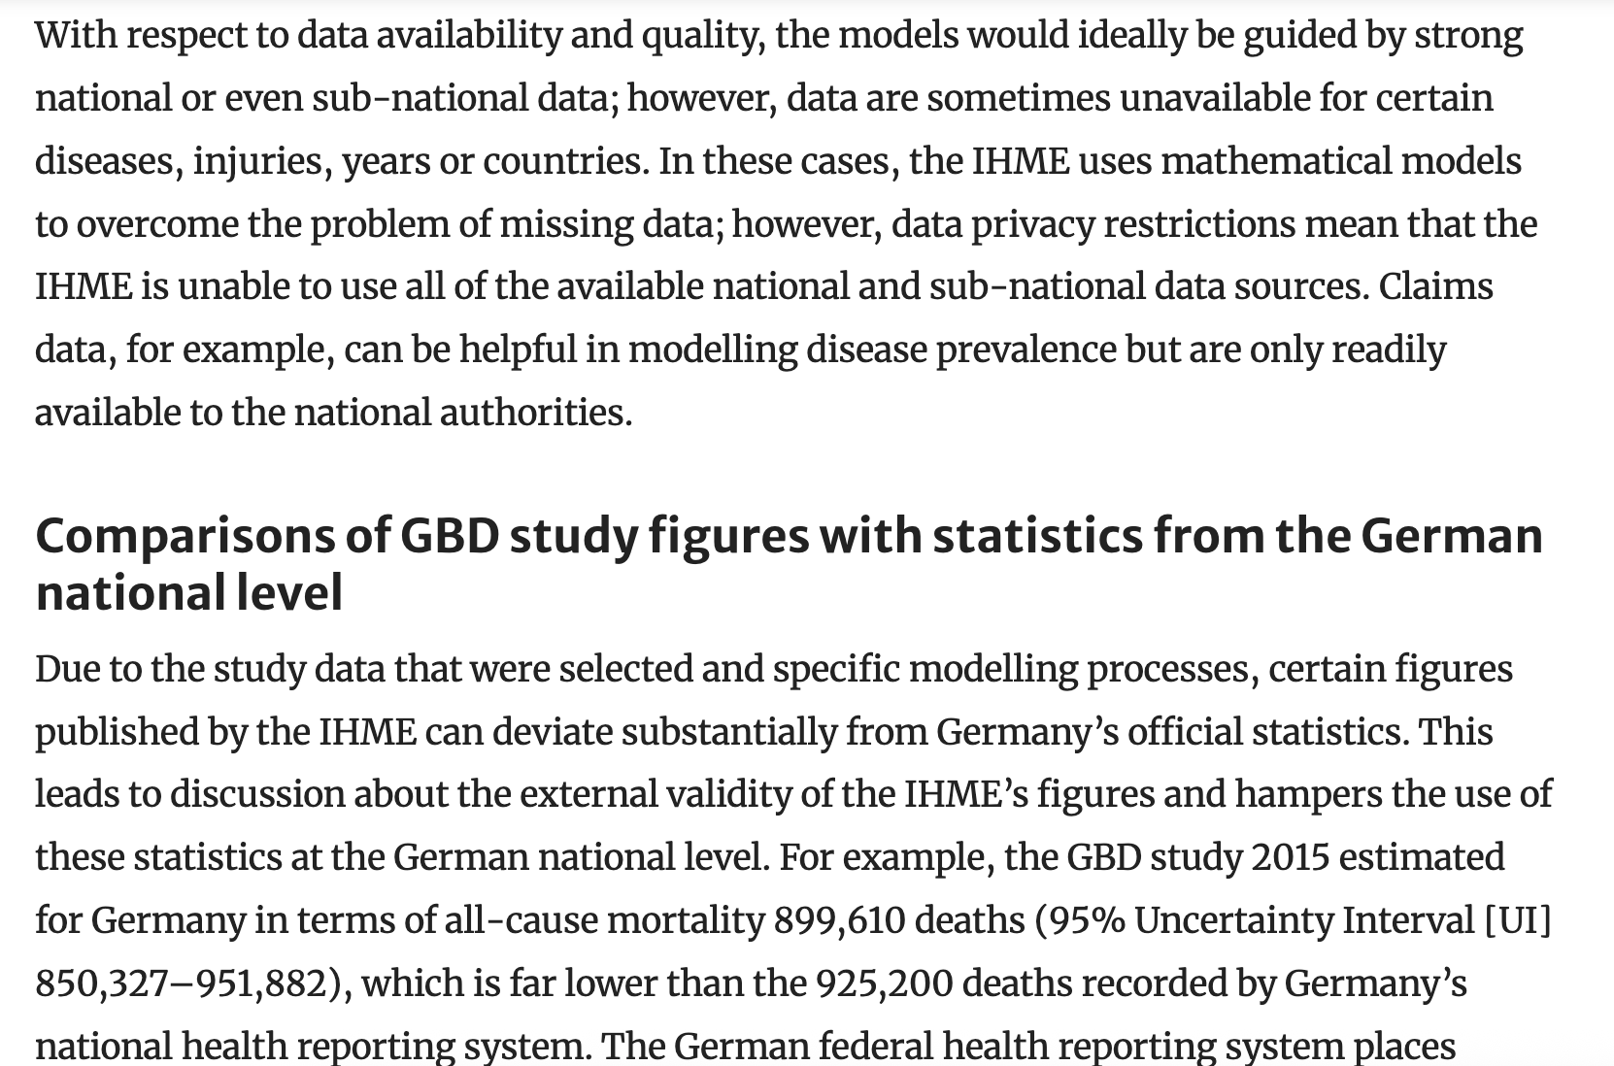

* Above
  + <https://link.springer.com/article/10.1007/s00103-018-2793-0>
  + The German federal health reporting system places a particular focus on diabetes (ICD-10: E10–E14) and recorded 24,400 deaths in 2015 [[7](https://link.springer.com/article/10.1007/s00103-018-2793-0#ref-CR7)]. Despite the fact that the GBD study includes additional ICD codes for diabetes, it provided an estimate of just 20,527 deaths (95% UI: 18,831–22,365). As such, the figures from the national level were not within the bounds of uncertainty ascribed to the GBD study’s estimate. Furthermore, diabetes-related deaths can be underestimated in the cause of deaths statistics as complications and comorbidities, such as cardiovascular diseases, are often reported as the underlying cause of death
  + One important reason for the differences between the GBD study data and official German statistics is that the IHME performs corrections of its vital statistics data. This is particularly important in cases where deaths were recorded using the wrong ICD-10 codes or “garbage codes” (where deaths are assigned to ICD-10 codes that cannot have been related to the underlying cause of death). The deviations can cause marked differences in DALYs which illustrates the need for methodological adjustments within a national burden of disease study. During this project, different data sources, including sources that are not considered by the IHME, can be analyzed and combined to produce improved estimates of the burden of disease
  + In addition to the fragmented data pool and the fact that differences between the GBD study and national statistics and studies are sometimes hard to grasp, the GBD study does not provide estimates on sub-national level for many European countries. In order to increase the external validity and acceptance of the figures provided by the IHME, several countries have established their own studies on the burden of disease.
  + he long-term goal is to provide a differentiated and continuous calculation of disease burden based on the available data in Germany

<https://link.springer.com/article/10.1186/s13690-020-00458-3?fromPaywallRec=true>

<https://www.tandfonline.com/doi/epdf/10.1016/S0968-8080%2811%2937550-7?needAccess=true>

- n the onehand, the scientific method is defined by inno-vation, transparency, critical evaluation and theconfrontation of alternative hypotheses. On theother hand, what is good from a scientific pointof view may be less so from a country perspec-tive, where multiple, often contradictory esti-mates create confusion and scepticism whichneed to be avoided

- In adjusting data from civil regis-tration, IHME conducted a detailed empiricalexamination of deaths classified to “ill-definedand unspecified causes”. The UN adjustmentto the PMDF derived from civil registration wasbased on a review of published literature on theextent of misclassification of maternal deathsreported in reproductive age mortality studies

- Interestingly, the two different approaches cameup with similar estimates of misclassification, leading to a 40% increase in maternal deaths inthe IHME study compared with 50% in the UNestimates

The authors of the GMatH model motivated their model by describing how the models produced by the MMEIG and GBD Study may inadequately describe country-specific trends [9]. More specifically, they described how the MMEIG and GBD estimates were based on statistical relationships between aggregate country-level factors and MMR, preventing them from modelling variation within a specific country [9]. In contrast, the GMatH estimates maternal mortality outcomes using microsimulations of individual women’s reproductive lifecycles, with parameters reflecting heterogeneity across the country, thus allowing the model to better represent country-specific variation [9]. Additionally, while the MMEIG and GBD models operate based on correlations between their covariates and the maternal mortality outcome being estimated, the GMatH estimates maternal mortality using causal relationships between risks and the stage of a woman’s reproductive lifecycle, with the GMatH model incorporating substantially more parameters than used in the MMEIG or GBD models [9]. Consequently, the GMatH model can produce more robust predictions based on causal-inference. By incorporating these causal relationships, the GMatH model can be used by policymakers to explore possible policies targeting maternal health [9]. Additionally, the breadth of parameters used by the GMatH model allows a wider variety of policies to be modelled and health system barriers to be explored [9]. For instance, the GMatH model has been used to estimate the difference between maternal mortality outcomes for women from rural versus urban backgrounds, as well as for women with different levels of education [10]. Through this analysis, the study authors found that, in 2022, the global MMRs for women with a low, middle, and high education level were 536, 143, and 85, respectively [10]. Thus, the authors identified the importance of addressing women’s education as an avenue for improving maternal mortality outcomes [10]. In contrast, it is difficult to produce an effective policy to reduce maternal mortality based on the observation that the MMEIG’s maternal mortality outcomes are primarily predicted by GDP, which is a difficult outcome for politicians to change [9].

However, as described by the GMatH authors, the model is computationally intensive, as all parameters must be estimated and the model must be calibrated [9]. This computational complexity can be observed across all three models, as they each require significant calibration and data processing as well as input from a variety of sources. The MMEIG’s outputs are the result of collaboration between multiple UN agencies as well as consultation between the group and representatives from each Member State [1]. The GBD estimates are similarly developed with a wide variety of collaborators, with the GBD 2021 estimates for different mortality indicators produced, reviewed, and analysed by a network of over 11,000 collaborators [6]. The GMatH model was similarly developed using consultation with experts as well as significant training and calibration [9].

This computation effort is compounded by the need to not only develop the sophisticated statistical models, but also to transform low quality data into a usable form and embed uncertainty in the data from different sources. As described above, the MMEIG produced an extra model for the sole purpose of adjusting the CRVS data to account for mistakes while the GBD estimates were produced after categorising data quality using a star-based system and implementing complex algorithms to re-label unspecific or incorrect causes of death within the input data [2, 4, 8]. The GMatH model introduced separate parameters solely to model site-specific underreporting of maternal deaths, and the authors noted that a limitation of their method was lack of data about the extent of uncertainty in surveys [9].

Additionally, the models had to decide on parameters, another computationally intensive endeavour relying on a mixture of iterative experimentation, empirical data, and expert opinion. This task was complicated by the need to consider multicollinearity given the nature of statistical models particularly versus just letting a decision tree weed out unimportant ones

Moreover, the three models suffer from a lack of data, especially from lower income countries [1, 6, 9]. Given that all models rely on expert opinion to describe anticipated relationships between candidate covariates and maternal mortality outcomes, they are exposed to potential subjectivity, especially if experts from a subset of countries are queried about country-specific trends. For example, lack of data meant that some parameters used in GMatH model were not predicted by informative priors [9]. Since the subgroups with the most missing data are likely to be the lowest-income, the parameter values chosen to represent these subgroups may be misrepresentative.

### Statistical Models versus Machine Learning Models

Given these limitations, I propose the use of a machine learning based approach to estimate maternal mortality, as motivated by the following comparison between statistical models and machine learning technologies.

The models above rely to some extent on inference, where they create a mathematical model of the data generation process

* Identified covariates versus patterns used in ml that may also be useful (especially as unaffected by multicollinearity, which makes it difficult to isolate relationships between covariates and target variable)
* Give within-country as well due to diversity of features used
* No assumptions of parameter values used
  + All finetuned

Additional aim:

* <https://www.sciencedirect.com/science/article/pii/S2666827025000714>
  + This gap particularly concerns relative strengths in scalability, robustness, and applicability to big data (Guo et al., 2021), creating opportuniti

More variables (10 below)

In addition, although previous analyses have focused on [health system](https://www.sciencedirect.com/topics/medicine-and-dentistry/health-system) and clinical interventions that can improve maternal health,[11](https://www.sciencedirect.com/science/article/pii/S2589537024002323" \l "bib11), [12](https://www.sciencedirect.com/science/article/pii/S2589537024002323" \l "bib12), [13](https://www.sciencedirect.com/science/article/pii/S2589537024002323" \l "bib13) fewer studies have explicitly examined the impact of [social determinants of health](https://www.sciencedirect.com/topics/medicine-and-dentistry/social-determinants-of-health), especially the role of women's education, which has been identified as a causal factor for healthcare utilization and maternal health outcomes in settings such as Peru and Uganda.[14](https://www.sciencedirect.com/science/article/pii/S2589537024002323" \l "bib14),[15](https://www.sciencedirect.com/science/article/pii/S2589537024002323" \l "bib15) In addition to examining the impact of women's education on maternal health outcomes, understanding the impact of geography (e.g., urban/rural location) on [reproductive health](https://www.sciencedirect.com/topics/medicine-and-dentistry/reproductive-public-health) factors and health system access can help inform policies to improve health equity within countries.

<https://pmc.ncbi.nlm.nih.gov/articles/PMC10298658/#abstract1>

* Table 7 compares usage frequency and best performance for bagging, boosting, stacking and voting algorithms used in the reviewed articles, as outlined in Tables 1–5. Although boosting has been frequently employed (37 of 45), the frequency of the most accurate in percentage is only 40.5%. Stacking, on the other hand, was used in 23 of the 45 studies, but the accuracy rate is 82.6%. Random forest and random subspace are the upgraded 15 of 21 version of bagging, so in this comparison analysis, these approaches have been included in the bagging section. Bagging has produced the poorest outcomes, with the highest accuracy of only 26.8% with a usage frequency of 41 out of 45. Voting has also shown a good frequency of the best performance accuracy of 71.4%, but it appeared in seven out of 45 reviewed articles
* Stacking is a popular and efficient strategy for heart disease, skin cancer, liver disease, and diabetes prediction. It can capture and combine varied predictions from base models, uncovering hidden patterns and complicated connections between risk factors and symptoms [10]. It also captures nonlinear relationships, taking advantage of the flexibility of various modelling techniques to capture nonlinear patterns more successfully than other ensemble methods, such as bagging or boosting [34]. Stacking can combine predictions from several base models trained on distinct subsets or representations of the data, exploiting the strengths of each model while limiting the impact of data heterogeneity. It can address class imbalance issues in imbalanced datasets by optimising performance on minority classes and incorporating models with various uncertainty handling strategies, such as imputation approaches or robust estimation methods [4,8,37]. R

1. Citation: Trends in maternal mortality estimates 2000 to 2023: estimates by WHO, UNICEF, UNFPA, World Bank Group and UNDESA/Population Division. Geneva: World Health Organization; 2025. Licence: CC BY-NC-SA 3.0 IGO
2. The Annals of Applied Statistics 2017, Vol. 11, No. 3, 1245–1274 DOI: 10.1214/16-AOAS1014 © Institute of Mathematical Statistics, 2017
   1. 2017 un mmeig estimates
3. <https://www.tandfonline.com/doi/full/10.1080/2330443X.2023.2286313#abstract>
   1. Bmis model information
4. <https://www.thelancet.com/cms/10.1016/S0140-6736(24)00367-2/attachment/b7b1d025-a598-408a-b62e-025ebc1f08d1/mmc1.pdf>
   1. Supplement to: GBD 2021 Causes of Death Collaborators. Global burden of 288 causes of death and life expectancy decomposition in 204 countries and territories and 811 subnational locations, 1990–2021: a systematic analysis for the Global Burden of Disease Study 2021. Lancet 2024; published online April 3. https://doi.org/10.1016/ S0140-6736(24)00367-2.
5. <https://www.nature.com/articles/s41591-022-01990-1>
   1. Gbd at 30 years
6. <https://www.thelancet.com/journals/lancet/article/PIIS0140-6736(24)00367-2/fulltext>
   1. Gbd 2021
7. <https://pophealthmetrics.biomedcentral.com/counter/pdf/10.1186/1478-7954-10-1.pdf>
   1. Foreman KJ, Lozano R, Lopez AD, Murray CJL. **Modeling causes of death: an integrated approach using CODEm**. Population Health Metrics. 2012; 10:1.
8. <https://bmcmedinformdecismak.biomedcentral.com/articles/10.1186/s12911-021-01501-1>
9. <https://www.nature.com/articles/s41591-023-02310-x>
   1. Ward, Z.J., Atun, R., King, G. *et al.* Simulation-based estimates and projections of global, regional and country-level maternal mortality by cause, 1990–2050. *Nat Med* **29**, 1253–1261 (2023). <https://doi.org/10.1038/s41591-023-02310-x>
10. <https://www.sciencedirect.com/science/article/pii/S2589537024002323>
11. <https://www.sciencedirect.com/science/article/pii/S2666827025000714>
12. <https://academic.oup.com/bmb/article/121/1/121/2926155>
13. <https://www.thelancet.com/journals/langlo/article/PIIS2214-109X(24)00560-6/fulltext>
    1. Lancet global determinants of MMR
14. <https://www.mdpi.com/1999-5903/15/8/255>
    1. Arima
15. <https://link.springer.com/article/10.3758/s13428-023-02204-3#Sec36>
    1. Bayesian hierarchical model tutorial

### Existing Use of Machine Learning Methods in Public Health

### Rationale for many features – limitations research

Over 70% of the indirect obstetric deaths pre-date pregnancy, such as from causes like non-communicable disease (NCDs), making NCDs a leading cause of maternal mortality [a, b]. For example, one of the major causes of maternal mortality between 2018 and 2020 in Australia was cardiovascular disease [a]. Other NCDs like diabetes, asthma and mental health conditions also commonly affect pregnant women, with guidelines currently being developed to improve management of NCDs during pregnancy for better health outcomes [a]. The

* Additionally, pregnancy is a unique time when underlying health conditions can be exacerbated and new conditions can develop (14). These affect the ongoing health of both the mother and child (13). For pregnant women with existing chronic conditions, NCD-related morbidity experienced during and after pregnancy often does not receive adequate consideration by healthcare worker
* Modifiable NCD risk factors refer to unhealthy behaviors that increase the risk of developing NCDs, such as tobacco use, harmful use of alcohol, physical inactivity, and an unhealthy diet. (29) These unhealthy habits also represent important risk factors for complications during pregnancy, fetal development and childbirth; which result in negative maternal, newborn, and child health outcomes
* Additionally, anemic women are more likely to die from postpartum hemorrhage, which is the leading cause of maternal death worldwide
* Studies suggest that a two-thirds reduction in MNCH deaths and a one-third reduction in premature NCD mortality will translate into 210,000 fewer maternal deaths and 690,000 fewer deaths among women of reproductive age, as well as reduce mortality by 2.4 million in women aged 50–69years
* Pregnancy is an opportune time in the lives of women to diagnose and manage underlying conditions, including NCD risk factors and existing NCDs which can lead to adverse MNCH outcomes, thereby improving the health of women and their children across the life course (12, 56). This integrated approach is well articulated in the 2016–2030 Global Strategy for Women’s, Children’s, and Adolescents’ Health that provides the framework for continued investment in evidence-based actions, including addressing NCDs to end preventable maternal, newborn, and child mortality and morbidity (57). B

**Give causes and discuss preventability**

1. <https://onlinelibrary.wiley.com/doi/10.5694/mja2.52452>
   1. Non-communicable disease and pregnancy
   2. Ramson et al., 2024
2. Akselrod S, Banerjee A, Collins TE, Acharya S, Artykova N, Askew I, Berdzuli N, Diorditsa S, Eggers R, Farrington J, Jakab Z, Ferreira-Borges C, Mikkelsen B, Azzopardi-Muscat N, Olsavszky V, Park K, Sobel H, Tran H, Vujnovic M, Weber M, Were W, Yaqub N, Berlina D, Dunlop CL and Allen LN (2023) Integrating maternal, newborn, child health and non-communicable disease care in the sustainable development goal era. Front. Public Health 11:1183712. doi: 10.3389/fpubh.2023.1183712
   1. More NCDs
3. Petersen EE, Davis NL, Goodman D, et al. Racial/Ethnic Disparities in Pregnancy-Related Deaths — United States, 2007–2016. MMWR Morb Mortal Wkly Rep 2019;68:762–765. DOI: <http://dx.doi.org/10.15585/mmwr.mm6835a3>

* This disparity persisted over time and across age groups. The PRMR for black and AI/AN women aged ≥30 years was approximately four to five times that for their white counterparts. PRMRs for black and AI/AN women with at least some college education were higher than those for all other racial/ethnic groups with less than a high school diploma
* Significant differences in cause-specific proportionate mortality were observed among racial/ethnic populations
* PRMR increased with maternal age; the black:white disparity was lowest among women aged
* Racial/ethnic disparities were present at all education levels. The PRMR among black women with a completed college education or higher was 1.6 times that of white women with less than a high school diploma. Among women with a college education or higher, the PRMR for black women was 5.2 times that of their white counterparts. The black:white disparity ratio in the PRMR for the states in the lowest, middle, and highest tertiles was 3.0, 3.3, and 2.8, respectively
* Thirteen state maternal mortality review committees reported 60% of pregnancy-related deaths were preventable, and there were no significant differences in preventability by race/ethnicity (1). Differences in proportionate causes of death among black and AI/AN women might reflect differences in access to care, quality of care, and prevalence of chronic diseases (4).
* Chronic diseases associated with increased risk for pregnancy-related mortality (e.g., hypertension) are more prevalent and less well controlled in black women (5). Ensuring access to quality care, including specialist providers, during preconception, pregnancy, and the postpartum period is crucial for all women to identify and manage chronic medical conditions (4). Systemic factors (e.g., gaps in health care coverage and preventive care, lack of coordinated health care, and social services) and community factors (e.g., securing transportation for medical visits and inadequate housing) have also been identified as contributors to pregnancy-related deaths (1). Addressing these factors and ensuring that pregnant women at high risk for complications receive care in facilities prepared to provide the required level of specialized care can improve outcomes
* Quality of care likely has a role in pregnancy-related deaths and associated racial disparities. A national study of five specific pregnancy complications found a similar prevalence of complications among black and white women, but a significantly higher case-fatality rate among black women (6). Studies have suggested that black women are more likely than are white women to receive obstetric care in hospitals that provide lower quality of care

1. [**https://pubmed.ncbi.nlm.nih.gov/27642018/**](https://pubmed.ncbi.nlm.nih.gov/27642018/)

* Yet maternity service use has increased substantially in the past 10 years since the 2006 Lancet maternal health Series: three-quarters of women now deliver with a skilled birth attendant and two-thirds receive at least four antenatal care visits worldwide.5,6 This mismatch between burden and coverage exposes a crucial gap in quality of care. Millions of women receive services that are delayed, inadequate, unnecessary, or harmful,7–9 minimising the opportunity for health gains for both mothers and babies
* The MDG5 target to reduce maternal mortality by 75% was not achieved. The gap between countries with highest and lowest mortality has increased despite increased use of maternity care.
* In parallel to the women accessing services but receiving poor-quality care, millions of women and adolescents who undertake their journey through pregnancy and childbirth outside the health system are left behind from the progress in coverage.
* Prevention of unwanted or poorly timed pregnancy is the fi rst step. By ensuring access to modern contraceptives for all women and adolescents, everywhere, this step could reduce maternal deaths by an estimated 29%.11 In 2015, 12% of women had unmet need for contraceptives,12 and approximately 7·9% of maternal deaths were attributed to unsafe abortion.13 Thus, safe abortion services are also important.
* In sub-Saharan Africa, infectious diseases, such as malaria and HIV, take their toll on maternal health and contribute to the burden of perinatal deaths.20,33–35 In settings with fewer of these infectious diseases or fewer deaths due to traditional direct causes, non-communicable diseases and mental health become more prominent, often in relation to older motherhood and obesity
* A substantial patient-safety literature identifi es movement between services as an important point when care breaks down. For example, antiretroviral therapy protocols for HIV-positive women identifi ed via antenatal care screening were adapted to require fewer visits to ensure high coverage of prevention of mother-to-child transmission in the narrow time-window before delivery.38 Reduction of maternal and perinatal deaths attributable to eclampsia or pre-eclampsia requires functional linkages between antenatal care and hospital-based services
* Women everywhere fail to seek care for numerous reasons, including sociocultural factors such as gender inequality, location because of remoteness or confl ict, and fi nancial constraints.40–46 These three major access barriers require immediate attention.
* Gender inequality refl ects power imbalances between men and women both within the household and in the wider societal context,47 and is both defi ned and perpetuated by sociocultural norms. Documented to varying degrees in every country worldwide,48 gender disparities aff ect women and maternal health through pathways directly49 (eg, early marriage and childbearing, decision making about care seeking, costs of care, and types of care sought) and indirectly50,51 (eg, education and availability of food). Gender-based violence, one of the most extreme forms of dis crimi nation against women, increases during pregnancy and directly aff ects maternal and perinatal
* Women living in remote areas or in areas of humanitarian crises face other challenges.40 Rural residence brings the obvious barrier of increased distance to hospitals
* Women in areas of humanitarian crises are among the super-vulnerable populations of fragile states. 16 countries49 are in the high-alert category of the Fragile States Index, and in nine, more than a third of women reside in confl ict areas. Many have high maternal mortality ratios: 60% were either seriously or moderately off target for MDG 5.62 High fertility and unwanted pregnancies are typically common, particularly among adolescents, and are often caused by sexual violence infl icted as a weapon of war
  + Despite increased need, maternal and reproductive health resources for even basic services such as family planning, obstetric emergencies, and comprehensive abortion care are insuffi cient or non-existent during humanitarian crises, especially in countries with preexisting weak health systems.64 For example, in the Ebola virus epidemic, maternal and infant mortality, which were already high before the outbreak, increased substantially during the crisis.65 Ensuring access and availability of these basic services is necessary every where, including in areas with humanitarian crises
* Financial constraints underlie much of the poor access to maternal health services in all settings.44–46 Poor subpopulations in low-income and middle-income countries still face catastrophic expenditures due to emergency obstetric care. In parts of Mali, for example, more than 50% of households needing emergency obstetric care incurred catastrophic expenditures
* Figure 2 compares the ratios of practising midwives, auxiliary midwives, nurse midwives, and obstetricians and gynaecologists to the number of pregnancies in African countries.80 It shows that countries with the largest numbers of births (eg, Democratic Republic of the Congo, Tanzania, Kenya, and Ethiopia) have some of the lowest densities of midwives and obstetricians (

1. [**https://pmc.ncbi.nlm.nih.gov/articles/PMC11117177/pdf/jogh-14-04128.pdf**](https://pmc.ncbi.nlm.nih.gov/articles/PMC11117177/pdf/jogh-14-04128.pdf)
   1. For example, pregnant and postpartum women, infants, and children have been found to have heightened vulnerability to climate risks due to a set of physiological, clinical, behavioural, and social factors that characterise these unique stages of life [3]. Pregnancy increases the vulnerability to climate-sensitive infectious diseases, particularly vector-borne diseases
   2. Climate change impacts maternal and newborn health (MNH) through a complex network of interconnected pathways that are exacerbated by geography, poverty, and women’s lack of empowerment [3] and that lead to overall amplification of existing health disparities
   3. There is a growing body of epidemiological evidence on the associations of climate hazards and related environmental exposures (such as air pollution) with health outcomes among pregnant women and newborns [10–12]. These findings have led to calls to action to protect MNH from the changing climate through both mitigation (reducing greenhouse gases) and adaptation (managing climate risks)
   4. he review by Bekkar et al [35] showed a disproportionate effect of air pollution and heat on pregnant women with certain medical conditions or specific race/ethnicities.
   5. For example, pregnant women with malaria are three times more likely to suffer from severe disease compared to their non-pregnant counterparts [103]. Climate change is projected to increase the seasonal transmission of malaria, as well as expand its range in the East African highlands and may make vector borne diseases hard to control
   6. The meta-analysis conducted by Pedersen et al. [45] found evidence of a 47% increase in the odds of hypertensive disorders of pregnancy per 5 μg/m3 increment of fine particulate matter (PM2.5), while increments of 10 μg/m3 of nitrogen dioxide (NO2 ) or coarse particulate matter (PM10) were associated with 23% and 11% increased odds of hypertensive disorders during pregnancy, respectively. In the review by Markozannes et al. [64], a 10 μg/m increase of PM2.5 levels during the third trimester was associated with an increased risk for hypertension in pregnancy (OR=2.177, 95% CI=1.710–2.773)
2. [**https://www.sciencedirect.com/science/article/pii/S2589537024002323**](https://www.sciencedirect.com/science/article/pii/S2589537024002323)
   1. Globally, improving women’s education was associated with a substantial reduction in the projected MMR in 2030
   2. Ensuring all women achieve a middle level of education (i.e., complete primary, less than secondary) was associated with a global MMR of 139 (95% UI 118–159), which was of similar magnitude to a family planning strategy (149 [95% UI 128–169]), or a community-based strategy that improves ANC coverage, skilled birth attendants for home births, and linkages to care (MMR of 136 [95% UI 117–154]). Ensuring all women complete secondary school was associated with an MMR of 97 (95% UI 76–120), which was of a similar magnitude to a strategy that increases facility births, availability of clinical services, and linkages to care (MMR of 104 [95% UI 87–121]).
   3. We provide the first estimates, to our knowledge, of within-country subgroup disparities for global maternal health outcomes
      1. My analysis of features could help do the same?
   4. Our analysis also shows that improving women’s education is associated with reductions in maternal mortality, with universal secondary education for women associated with a substantial reduction in the global MMR, on a par with modeled interventions that increase facility births, availability of clinical services, and linkages to care. However, the wide disparities that exist in women’s education globally means that the gains expected from improvements in education would be greater in selected countries
   5. Using our individual-level structural model of maternal health which allows for flexible aggregation of model outcomes, we leverage information on observed subgroup differences in intermediate factors to estimate differences in maternal health outcomes. Although we do not have subgroup-specific estimates of these outcomes, we do have subgroup-specific parameters that yield model predictions consistent with empirical data for women overall.3 This approach could be generalized to other topics where only marginal (overall) outcomes are observed, but subgroup-specific information on intermediate factors are available. Although empirical data are often lacking, and there is typically wide uncertainty around estimates that are available, our modelling approach can be used to examine trends in maternal health indicators by subgroup and the potential impact of policies to improve health equity
      1. Motivating my approach
3. [**https://www.thelancet.com/action/showPdf?pii=S2214-109X%2823%2900468-0**](https://www.thelancet.com/action/showPdf?pii=S2214-109X%2823%2900468-0)
   1. This paper argues that the preventable deaths of millions of women each decade are not solely due to biomedical complications of pregnancy, childbirth, and the postnatal period, but are also tangible manifestations of the prevailing determinants of maternal health and persistent inequities in global health and socioeconomic development. This paper underscores the need for broader, multipronged actions to improve maternal health and wellbeing and accelerate sustainable reductions in maternal mortality. For women who have pregnancy, childbirth, or postpartum complications, the health system provides a crucial opportunity to interrupt the chain of events that can potentially end in maternal death
   2. In 2015, world leaders committed to promoting peace, prosperity, health, and global cooperation to ensure the sustainability of human civilisation by setting the Sustainable Development Goals (SDGs).1 However, emerging priorities, such as the COVID-19 pandemic with its evolving consequences, the pressing climate emergency, conflicts, and political instabilities, have competed for attention and resources.2–5 In this context, previous and persistent challenges, such as maternal mortality, risk being neglected.5,6 At the halfway mark to 2030, the goal of reaching a global maternal mortality ratio (MMR) of 70 maternal deaths per 100000 livebirths remains elusive, with 223 maternal deaths per 100000 livebirths reported in 2020. This figure is much less than the MMR for 2000, which was 339 maternal deaths per 100000 livebirths. However, since 2016, the MMR has decreased in only two regions: central and south Asia, and Australia and New Zealand. Sub-Saharan Africa, Oceania (excluding Australia and New Zealand), east and southeast Asia, and north Africa all experienced a stagnation in the MMR. During this time period, the MMR increased in Europe, North America, Latin America, and the Caribbean.
   3. 8 Despite the large gains made in many countries in terms of improved agency, education, employment, and fertility desires for women, these advances have not been universal—most maternal deaths remain preventable and are largely clustered among groups of socioeconomically disadvantaged women. Disease outbreaks, conflicts, and other public health emergencies aggravate the situation by increasing the risk of pregnancy complications, disrupting health systems, and posing additional constraints to maternal and perinatal healthcare.
   4. • Focusing solely on biomedical causes of maternal mortality is insufficient, and has possibly been the cause of many countries remaining at the same maternal mortality transition stage for decades (121 out of 185 countries analysed have been in the same maternal mortality transition stage for 20 years)
   5. The most common approach to tackling maternal mortality by the global community has been to direct investments to address the leading biomedical causes of maternal death, particularly during the perinatal period. Compared with biomedical causes, less attention has been paid to the underlying determinants of adverse pregnancy and childbirth outcomes and how health systems could be configured to implement effective interventions and mitigate the adverse effects of social factors on materna
   6. The necessary technologies, commodities, and services to effectively reduce maternal mortality already exist. Mortality could be substantially reduced if qualityassured maternal health commodities and services were consistently available, and if unwanted pregnancies were prevented in the first place by increasing access to modern contraception
   7. We reviewed the literature for conceptual frameworks of the determinants of maternal health (appendix p 3). We identified 23 frameworks portraying maternal health and wellbeing as the result of a multifactorial process
   8. **A close up of words

      AI-generated content may be incorrect.**
   9. exposure to external agents (eg, physical, chemical, and biological hazards, infections, accidents, and violence) are major maternal health determinants. Teenage pregnancies and pregnancies in women older than 35 years are associated with an increased risk of some complications, such as preeclampsia.48,49 Women with pre-existing conditions, such as hypertension, diabetes, cardiac disease, and obesity, are at a higher risk of dying during pregnancy, childbirth, and the postpartum period than those who do not have pre-existing conditions. Genetic disorders, such as haemoglobinopathies (eg, sickle-cell anaemia, thalassaemia major), haemophilia, hereditary thrombophilia, and hypertrophic cardiomyopathy, can increase the risk of maternal complications and potentially lead to death.50–53 Exposure to environmental toxins and industrial chemicals (eg, lead, mercury, pesticides, air pollutants), medications and recreational drugs, ionising radiation, pathogenic threats (eg, Ebola virus, SARS-CoV-2), intimate partner violence, and accidents resulting in physical trauma and injuries have varying degrees of detrimental effects on maternal health outcomes, depending on a woman’s unique circumstances and level of exposures. Violence against women deserves special mention: although violence is often more visible in conflict-affected areas, the effects on pregnancy outcomes are equally devastating even in non-conflict areas, particularly when perpetrated by an intimate partner.54
   10. Cultural factors also influence decisions on nutrition, antenatal care practices, and childbirth practices. Societal expectations and gender roles can affect pregnant women’s autonomy, access to education, resources, and health care, and influence their decision-making power within their households, as well as their ability to make decisions about their own health, where they work, and what they do
   11. Complications of health interventions (ie, iatrogenic factors) are an important contributor to all-cause mortality and a substantial cause of or contributing factor to maternal mortality.7
   12. Tackling maternal mortality will require broader actions that go beyond biomedical causes, which manifest at a late stage in the events between a healthy state and severe morbidity or death. Policy makers, particularly those in countries with high maternal mortality burden, must recognise that the main biomedical causes (eg, postpartum haemorrhage, preeclampsia, infection, and abortion) of preventable maternal deaths do not happen in isolation
   13. That 121 countries have remained in the same mortality transition bracket for the past two decades is therefore unsurprising. For countries to progress across transition stages in their mortality reduction efforts, there must be renewed focus on strategies to address the underlying determinants described in the previous sections.
   14. Future research should aim to establish the correlation between key determinants and stages of the maternal mortality transition at national or regional levels to facilitate evidence-informed and individually tailored strategies and rapidly accelerate countries towards a very low maternal mortality transition stage.
4. [**https://www.sciencedirect.com/science/article/pii/S014067361360803X?via%3Dihub**](https://www.sciencedirect.com/science/article/pii/S014067361360803X?via%3Dihub)
   1. In sub-Saharan Africa, the high prevalence of HIV infection in pregnant women makes the interaction between HIV and maternal mortality an important public health issue
   2. A model developed by the Institute of Health Metrics and Evaluation assumed that all deaths in HIVinfected pregnant or post-partum women should be classifi ed as maternal; as a result, roughly 20·5% of maternal deaths in 2011 were attributed to HIV globally.5 Another model, which was produced by the UN Maternal Mortality Estimation Inter-agency Group, assumed that only 50% of deaths in HIV-infected pregnant or postpartum women were maternal; 6·5% of the global maternal deaths in 2010 were estimated to be attributable to HIV/AIDS on the basis of this model.4
      1. Check this for current models
   3. to HIV/AIDS on the basis of this model.4 An alternative measure of the contribution of HIV to mortality during pregnancy is the excess mortality associated with HIV in pregnant or post-partum women. On the basis of a systematic review13 of 23 studies, 17 of which were done in sub-Saharan Africa, HIV-infected pregnant or post-partum women were estimated to have nearly eight times the risk of death that non-HIV-infected women had. The authors of the review, which was focused on pregnancy-related mortality rather than maternal mortality, used this risk ratio to predict that roughly 25% of pregnancy-related deaths in sub-Saharan Africa were attributable to HIV.
   4. Excess mortality attributable to HIV was substantially lower in HIV-infected pregnant or post-partum women than that in HIVinfected women who were not pregnant or post partum. Thus, the HIV PAF is much smaller for pregnant or post-partum women than for women who were not pregnant or post partum (78%). Lower excess mortality attributable to HIV in HIVinfected pregnant or post-partum women than in HIVinfected women who are not pregnant or post partum is perhaps not surprising. Although HIV has been classi fi ed by some analysts as an indirect cause of maternal death5 — implying that HIV disease progression is aggravated by pregnancy—evidence for the adverse eff ect of pregnancy on HIV progression and mortality in HIV-infected women is weak.7 Excess mortality might be counter-balanced by the fact that fertility falls rapidly with duration of HIV infection34 and with age, whereas mortality increases with age and rises very rapidly with duration of HIV infection. When women are ill with AIDS or an AIDS-related disorder, they are unlikely to become pregnant and are thus unlikely to die while pregnant or post partum. T

**i)** [https://doi.org/10. 1016/j.eclinm.2023. 102180](https://doi.org/10.%201016/j.eclinm.2023.%20102180)

- Maternal health inequities are some of the most pervasive in global health. While significant progress has been made in some contexts, in many others it has flatlined, and in some cases reversed due to backlash against human rights. The maternal health target of Sustainable Development Goal 3 will not be achieved if we do not adopt an intersectional approach.

- Pregnancy and childbirth are explicitly tied to sexuality, reproductive health, and human rights, which are governed by heteronormative gendered power relations. T

- Using an intersectionality approach allows for explicit exploration of how gendered power relations interact with other sources of inequality to shape or impair agency, cultural expectations, and access to resources, support, and care during the perinatal period. In some gender inequitable societies, girls may be pushed into early marriage and childbearing, especially among families living in poverty in rural areas.8,9 Similarly, unmarried and adolescent mothers, who may be more likely to live in poverty, describe feeling socially stigmatised and mistreated by healthcare institutions and providers.10,11 Women and birthing people may have limited agency and bodily autonomy throughout pregnancy and childbirth; for example, limited autonomy over the decision to seek healthcare or financial resources to do so,12,13 or fear that gendered assumptions about pregnant bodies may result in lack of genderaffirming healthcare.14 They can be mistreated during childbirth, particularly where there are organisational challenges to providing care15 or lack of person-centred maternity care.16

who:

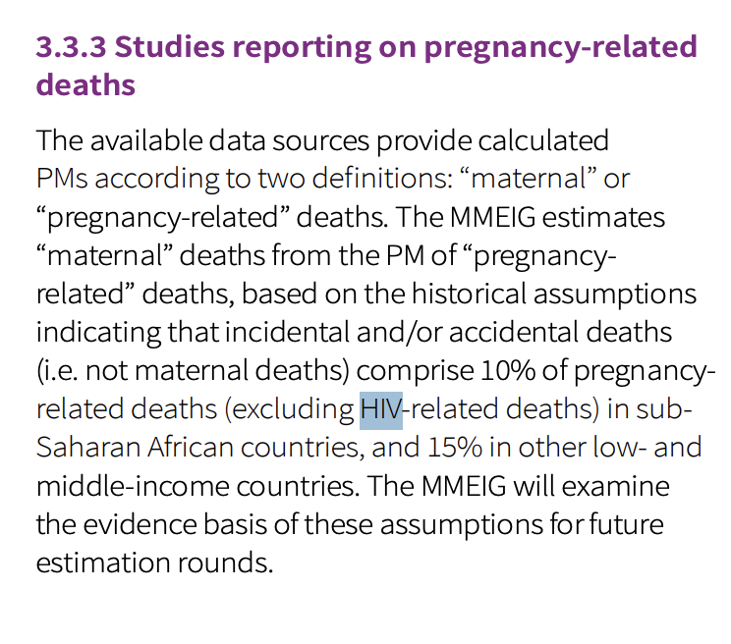

* This is less than studies have shown

* But we have just shown this to be insufficient

<https://pmc.ncbi.nlm.nih.gov/articles/instance/11946934/bin/mmc1.pdf> (appendix 5)

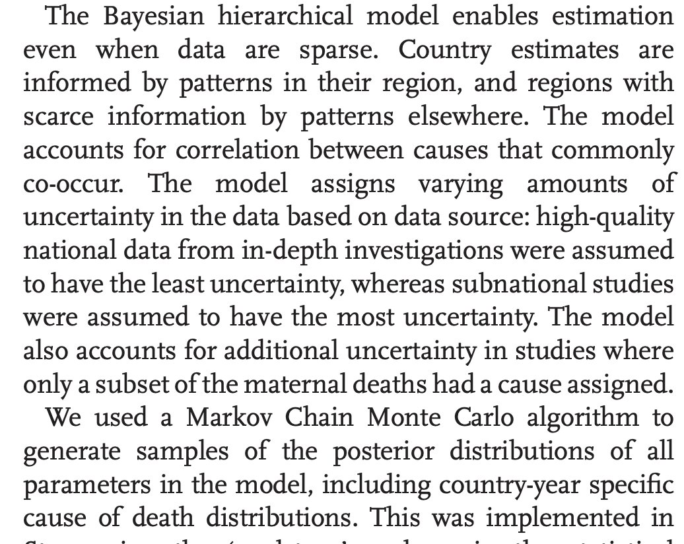

Other uses for ml in healthcare

* <https://www.clinicalkey.com.au/service/content/pdf/watermarked/1-s2.0-S2214109X24005606.pdf?locale=en_AU&searchIndex=>
* Showing how ml is used in public health research

My dta source

* Higher quality

<https://pmc.ncbi.nlm.nih.gov/articles/PMC4196216/#S5>

* This leads to estimates that borrow strength from data for other countries and makes the model hierarchical. This is important because, for a single country, the data are sparse (at most 12 five-year periods for most countries), and estimation of the country-specific double-logistic curve can be unstable, as it involves estimating five parameters from 12 or fewer data points.

<https://link.springer.com/article/10.3758/s13428-023-02204-3>

* In hierarchical analyses, the general or overall effect is sometimes called the fixed effect, and the individual-specific deviations from this effect are in that case referred to as random effects (Rouder & Lu, [2005](https://link.springer.com/article/10.3758/s13428-023-02204-3#ref-CR79)). We can also estimate individual effects, not as deviations from an overarching effect, but as effects for each individual, as obtained from a per-participant analysis. Throughout this tutorial, we will use the terms general effect, individual deviation, and individual effect.
* If estimated for each participant independently, observed individual effects are quite variable because they are perturbed by sample noise. In hierarchical modeling, these individual effects are optimally and automatically corrected towards the general trend (Efron & Morris, 1977). This phenomenon, also called “shrinkage,”
* Bayesian analysis requires the specification of prior distributions. Prior distributions are probability distributions on model parameters that specify beliefs about the relative plausibility of parameter values before seeing the data (Wagenmakers et al., 2018). These prior beliefs can then be updated with the data to obtain the posterior beliefs about the model parameters, following Bayes’ rule (Jeffreys, 1961)
* In the case of improper priors, it is often impossible to obtain correct estimation of general and individual effects in hierarchical models because the resulting posteriors will again be improper probability distributions

Micro simulations

<https://journals-sagepub-com.virtual.anu.edu.au/doi/epdf/10.1177/0894439310370084>

* Over 50 years ago, economist Guy Orcutt (1957) proposed a form of computer-based simulation that now is called microsimulation. The defining characteristic of this new type of model was that it modeled processes at the individual (micro) level but aggregated the results so that conclusions could be drawn at the macro level. Orcutt and colleagues went on to develop a microsimulation model(Orcutt, Greenberger, Korbel, & Rivlin, 1961), despite having to put up with extremely primitivecomputing technology. The model that Orcutt proposed would now be considered a dynamic micro-simulation model. By dynamic, we mean that it is a model that follows individuals through time

**Planning:**

* GBD
* microsimulation